Page/Date/Time 1 8/1/2014 1:18:22 PM
Database C:\Users\emariano\Desktop\FAER Analysis\FAER survey data.S0

Box Plot Section

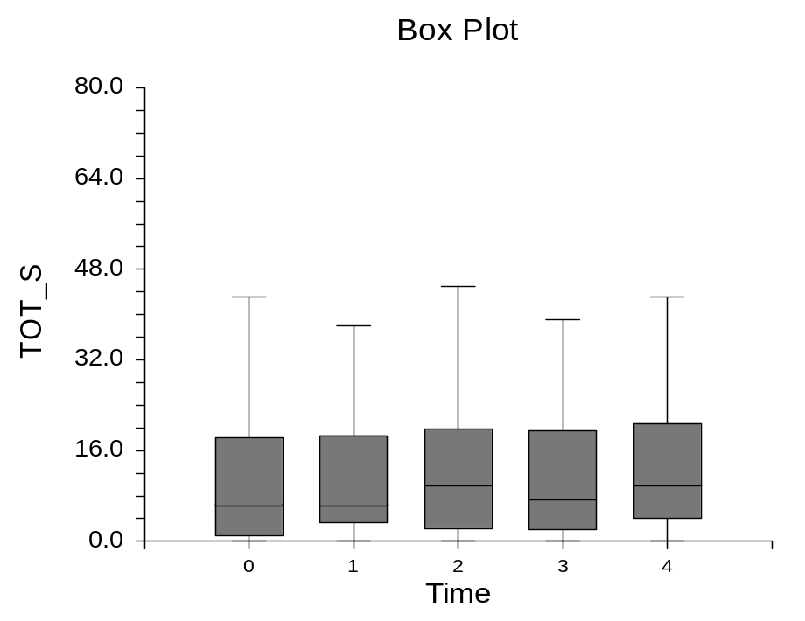
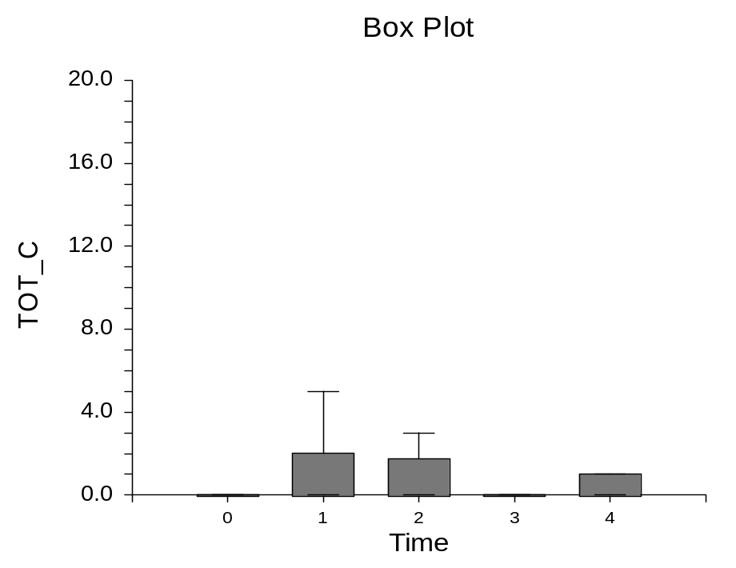

Page/Date/Time 2 8/1/2014 1:18:22 PM
Database C:\Users\emariano\Desktop\FAER Analysis\FAER survey data.S0

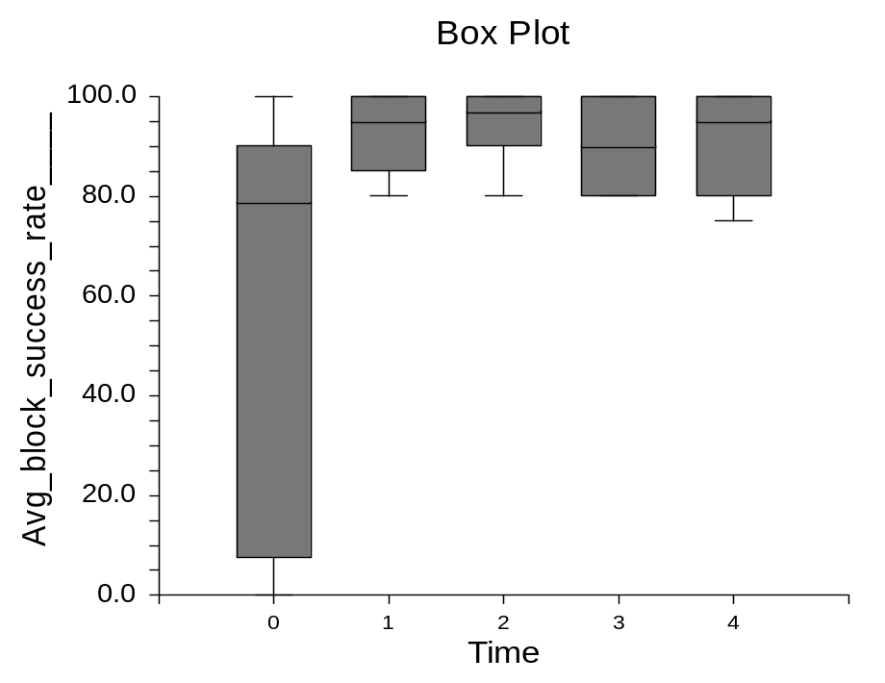
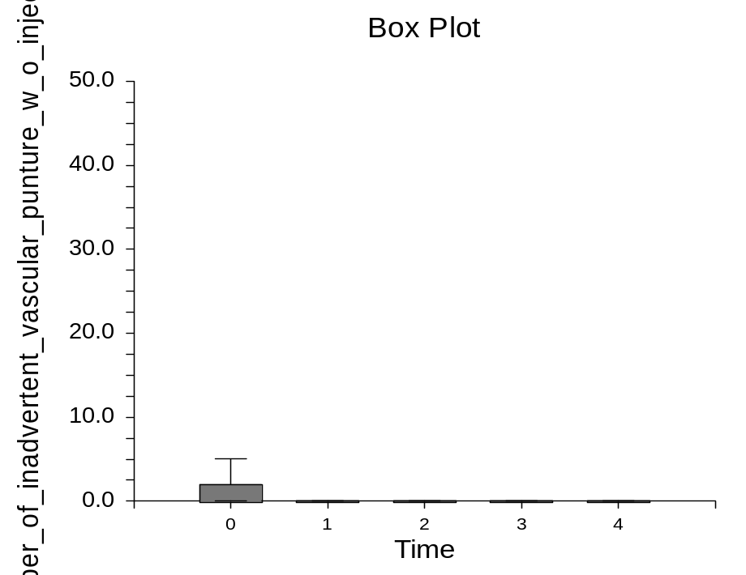

Page/Date/Time 3 8/1/2014 1:18:22 PM
Database C:\Users\emariano\Desktop\FAER Analysis\FAER survey data.S0

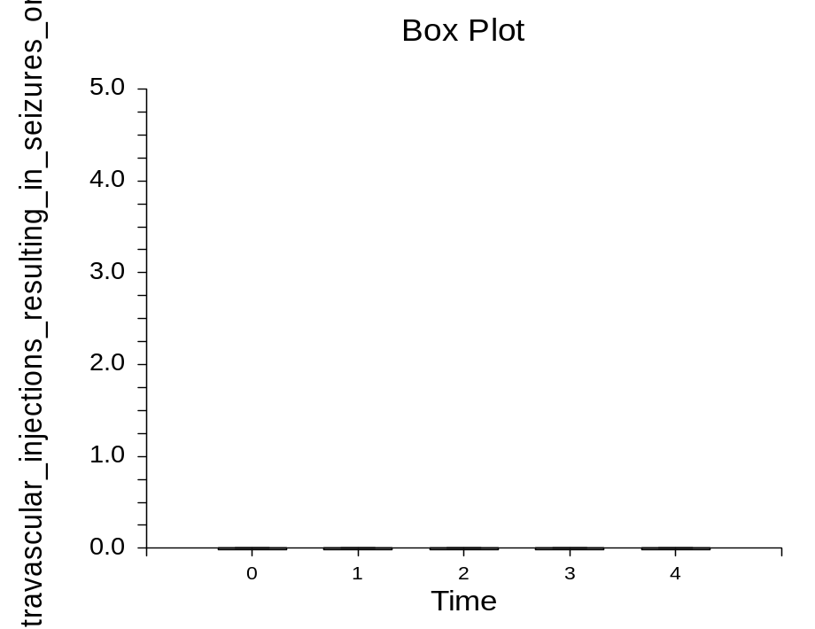
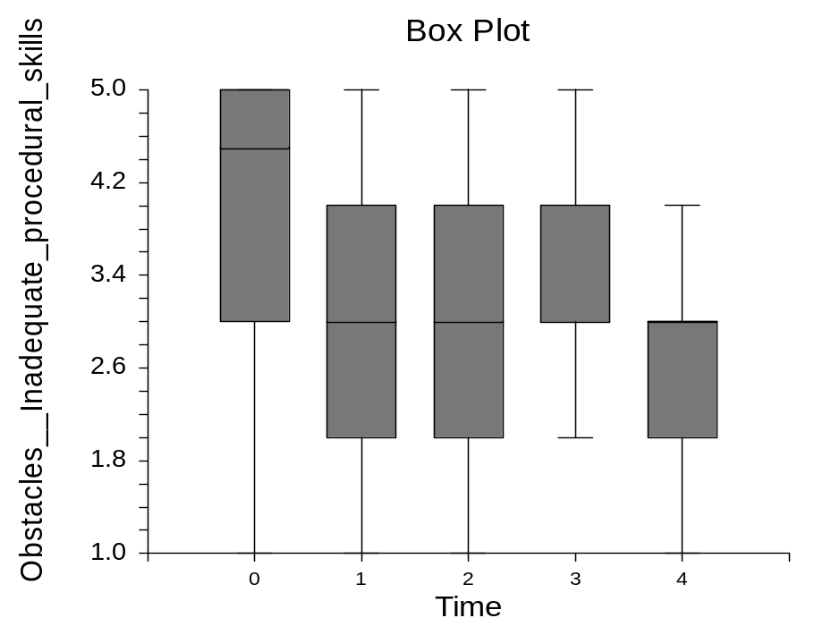

Page/Date/Time 4 8/1/2014 1:18:22 PM
Database C:\Users\emariano\Desktop\FAER Analysis\FAER survey data.S0

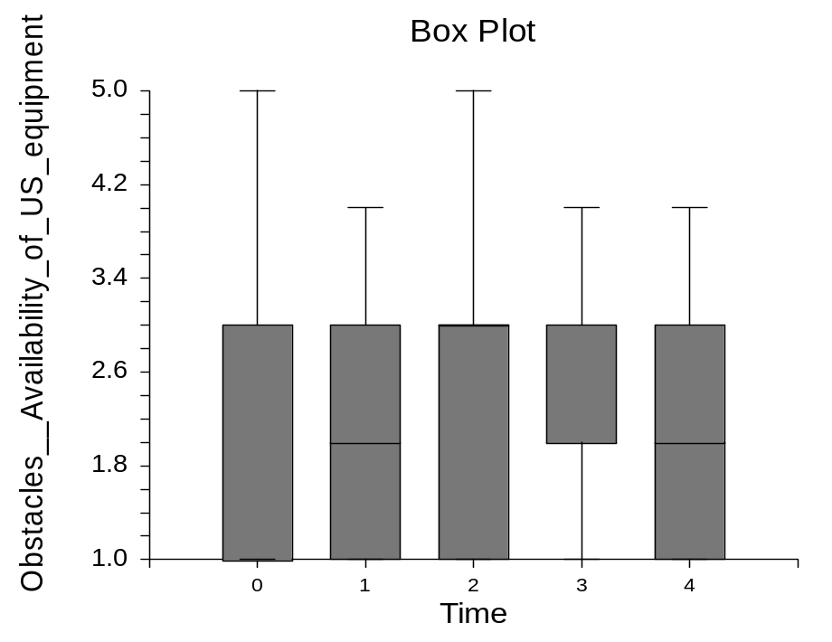
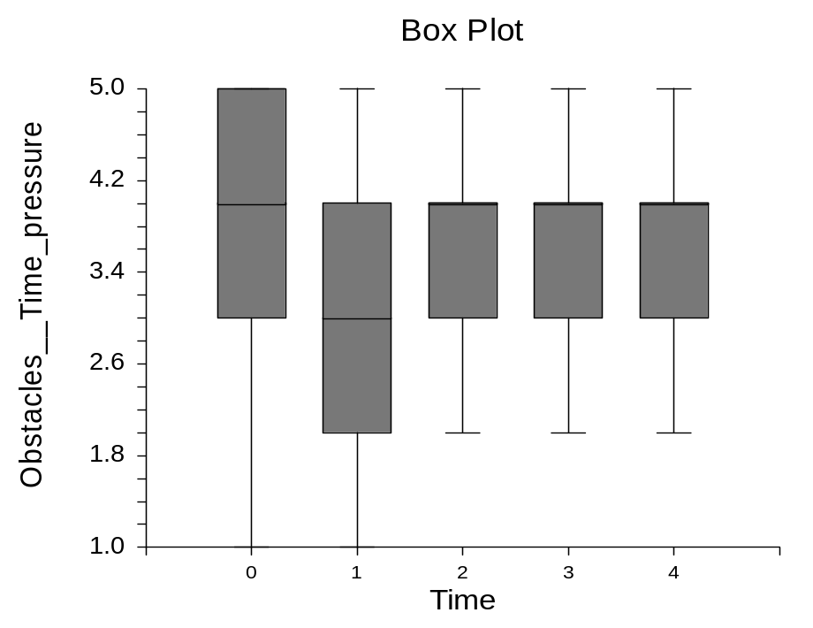

Page/Date/Time 5 8/1/2014 1:18:22 PM
Database C:\Users\emariano\Desktop\FAER Analysis\FAER survey data.S0

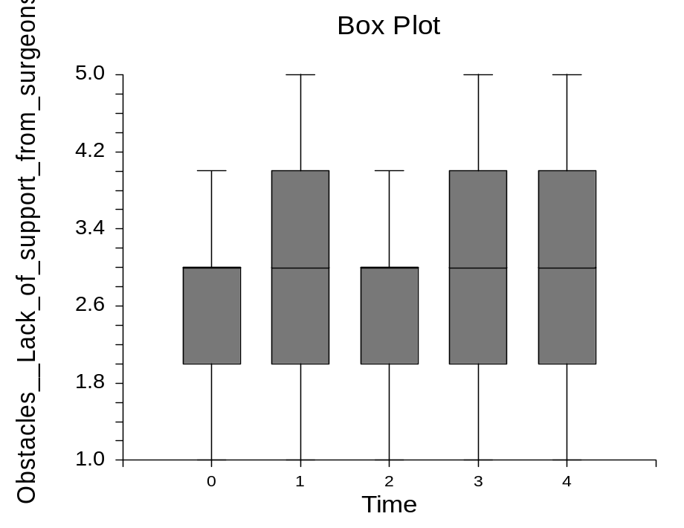
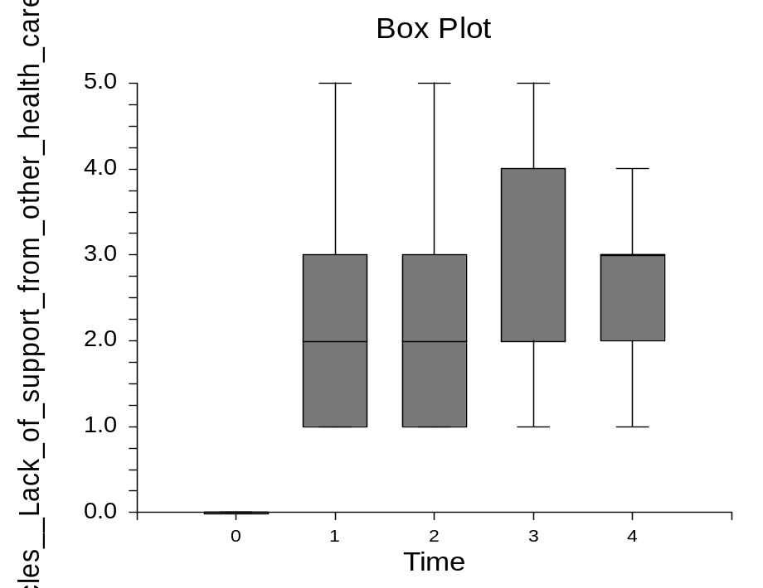

Page/Date/Time 6 8/1/2014 1:18:22 PM
Database C:\Users\emariano\Desktop\FAER Analysis\FAER survey data.S0

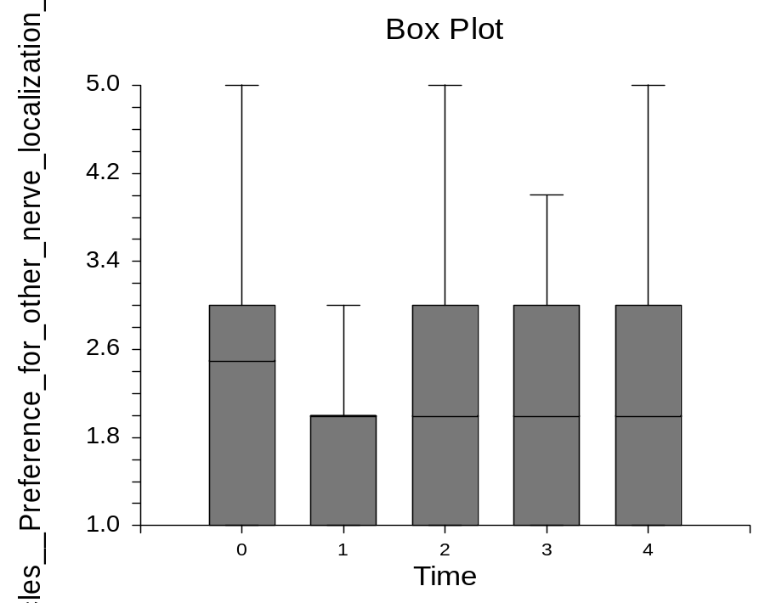
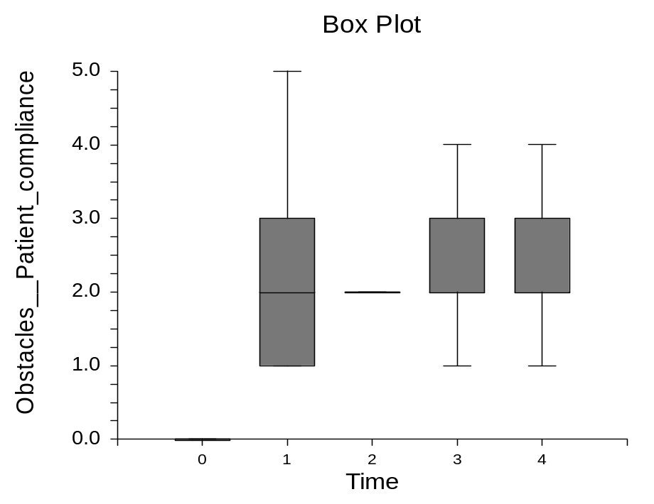

Page/Date/Time 7 8/1/2014 1:18:22 PM
Database C:\Users\emariano\Desktop\FAER Analysis\FAER survey data.S0

